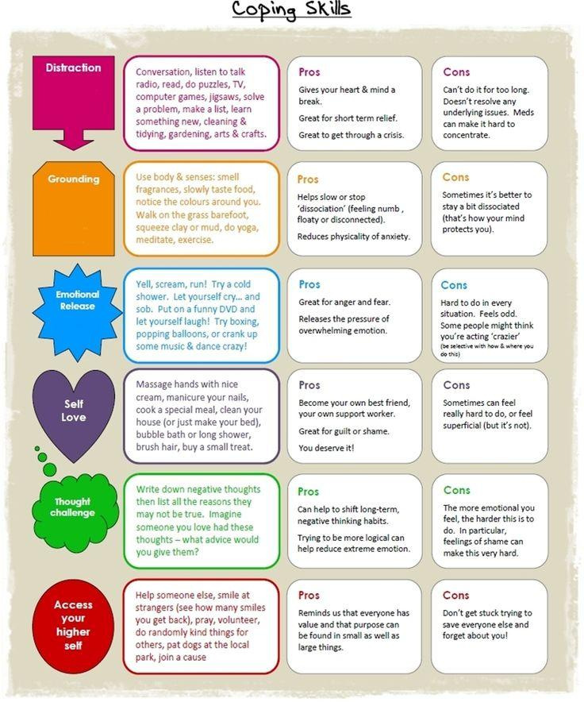
Source: https://myjourneywithdepression.wordpress.com/2013/02/21/coping-skills-2/. Created by Indigo Daya

